Q1) What is the net present value of a project with the following cash flows if the required rate of return is 9 percent?
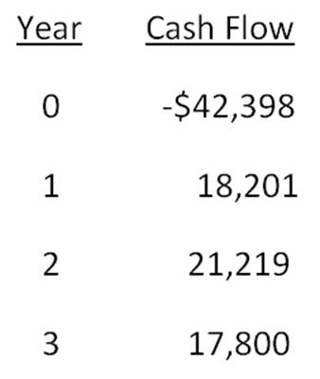

Q2) What is the net present value of a project that has an initial cash outflow of $34,900 and the following cash inflows? The required return is 15.35 percent.
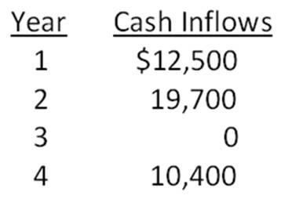
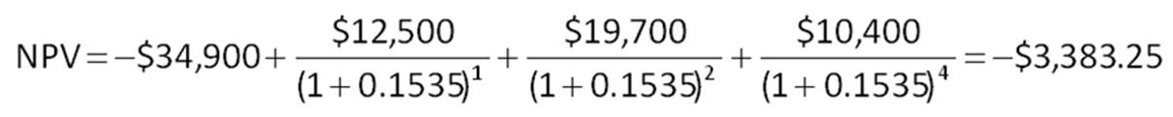

Q3) You are considering two mutually exclusive projects with the following cash flows. Which project(s) should you accept if the discount rate is 8.5 percent? What if the discount rate is 13 percent?
