Q1
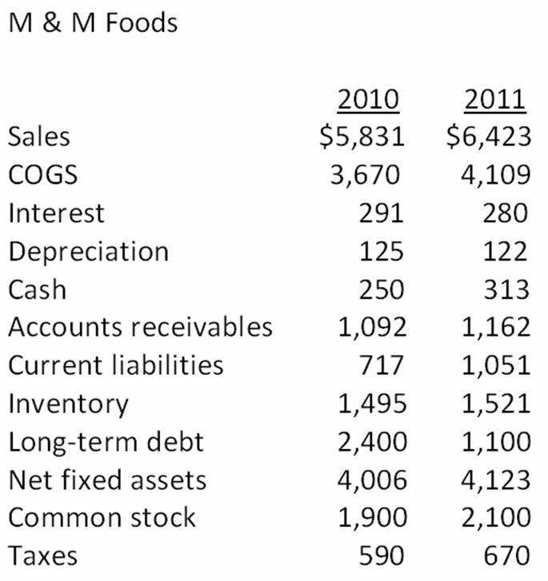
- What is the net working capital for 2011?
- What is the change in networking capital from 2010 to 2011?
- What is the net capital spending for 2011?
- What is the Free-Cash Flows?
Q2) Atlas Insurance wants to sell you an annuity which will pay you $1,600 per quarter for 25 years. You want to earn a minimum rate of return of 6.5 percent. What is the most you are willing to pay as a lump sum today to buy this annuity?
Q3) Your insurance agent is trying to sell you an annuity that costs $230,000 today. By buying this annuity, your agent promises that you will receive payments of $1,225 a month for the next 30 years. What is the rate of return on this investment?

Q4) The common stock of Auto Deliveries sells for $28.16 a share. The stock is expected to pay $1.35 per share next year when the annual dividend is distributed. The firm has established a pattern of increasing its dividends by 3 percent annually and expects to continue doing so. What is the market rate of return on this stock?
Q5) What is the net present value (and IRR) of a project that has an initial cash outflow of $34,900 and the following cash inflows? The required return is 15.35 percent.
