AF 325: Theory of Corporate Finance

Midterm Exam

General Instructions

1. Write your name below.

2. Time Allowed: 1 hour and 15 minutes

3. Closed Book, Closed Notes. No Smart phone and No Laptop. You can use a calculator.

4. Total Number of Points: 100+5 (Bonus)

5. You must show calculations to receive full credit for questions requiring a numeric answer. No work=no points. No Exceptions.

Name: ___________________________________

Professor: H. Zafer Yuksel

Q1)
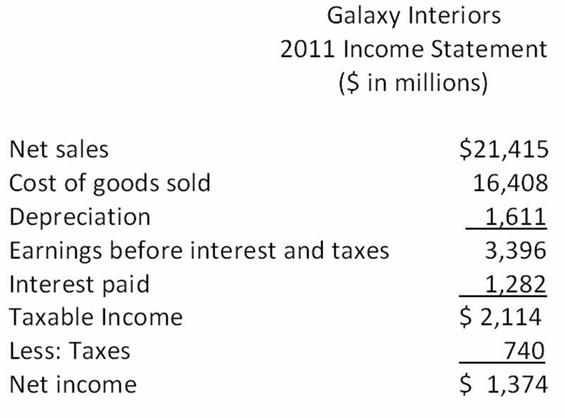
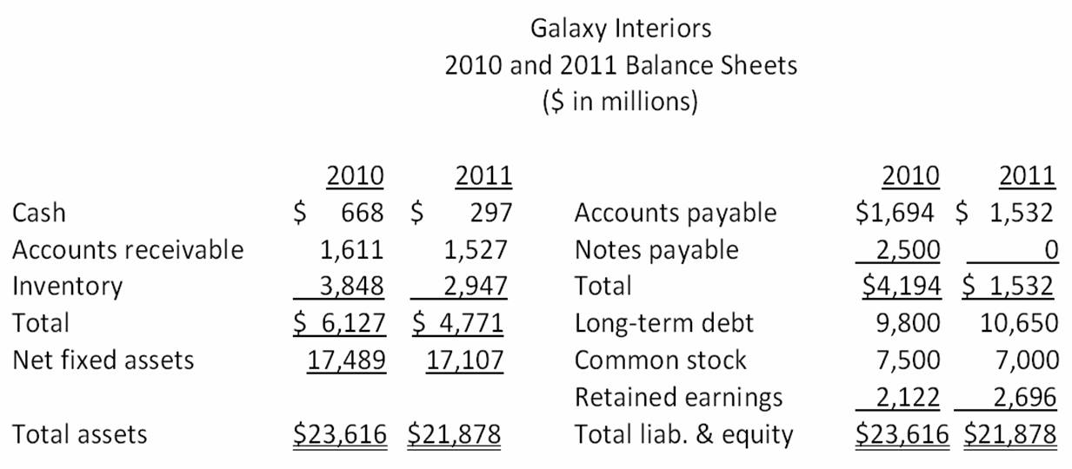
- What is the working capital in 2010 and 2011? (5 pts)
WC in 2011=3,239
WC in 2010=1,933

- What is the change in net working capital? (5 pts)

CHANGE in WC=1,306

- What is the free cash flows in 2011? (5 pts)

FCF=1,300

- Free Cash Flows are projected to be increasing by 6% for the first three years (2012, 2013, and 2014) and increasing by 3% forever after then? What is the stock price of this company? (Number of Shares outstanding is 1000 and Discount rate for this company is 10%) (10 pts)

P=$20.74

Q2) Both Bond S and Bond T are 4 percent coupon bonds, make semi-annual payments. They have a yield-to-maturity of 7 percent. While Bond S has 5 years to maturity, Bond T has 10 years to maturity
- If interest rates suddenly rise by 2 percent, what will the percentage change in the price of Bond S and Bond T? (10 pts)

PERCENTANGE CHANGE IN PRICE (S)=-8%
PERCENTANGE CHANGE IN PRICE (T)=-14%

- How could you explain these results? Why do they have different sensitivity to interest rate changes? (5 pts)

Q3) Bonner Metals wants to issue new 18-year bonds for some much-needed expansion projects. The company currently has 11 percent bonds on the market that sell for $1,459.51, make semiannual payments, and mature in 18 years. What should the coupon rate be on the new bonds if the firm wants to sell them at par? (10 pts)
YTM=6.6%

Q4 (Bonus)) The yield-to-maturity on a bond is the interest rate you earn on your investment if interest rates do not change. If you actually sell the bond before it matures, your realized return is known as the holding period yield. Suppose that today, you buy a 12 percent annual coupon bond for $1,000. The bond has 13 years to maturity. Two years from now, the yield-to-maturity has declined to 11 percent and you decide to sell. What is your holding period yield? (5 pts)

14.89%

Q5) Renew It, Inc., is preparing to pay its first dividend. It is going to pay $0.45, $0.60, and $1 a share over the next three years, respectively. After that, the company has stated that the annual dividend will be $1.25 per share indefinitely. What is this stock worth to you per share if you demand a 10.8 percent rate of return on stocks of this type? (10 pts)

P=$10.14

Q6) You are considering the following two mutually exclusive projects.
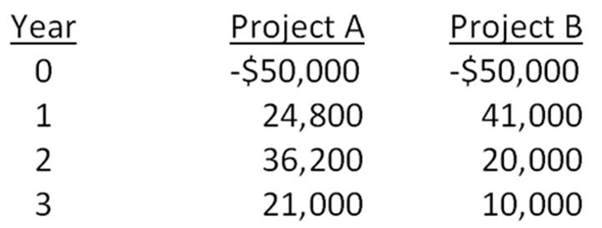
- The required rate of return is 14.6 percent for project A and 13.8 percent for project B. Which project should you accept and why? (10 pts)

NPV(A)=13,157
NPV(B)=8,256

- What are the Internal Rate of Returns (IRRs) for these projects? Is IRR helpful to make a decision? Why? (Hint: Remember these projects are mutually exclusive) (10 pts)

IRR(A)=30.07%
IRR(B)=26.24%

Q7) What is the relation between Nominal and Real Rate of Returns? Please briefly explain. (7 pts)

Q8) Let’s suppose Target’s P/E ratio is 12.34x. How could we know if earnings multiplier (P/E) is too high or too low? (7 pts)

Q9) We learn that NPV analysis is superior to other tools used in making investment decisions (such as Payback Period, Average Accounting Return and IRR), please explain why do we need these other tools? (6 pts)

Formula Sheet:
Perpetuity:
$$PV=\frac{CF}{r}$$
Growing Perpetuity:
$$PV=\frac{CF}{r-g}$$
Annuity:
$$PV=\frac{CF}{r}\left[1-\frac{1}{{(1+r)}^{T}}\right]$$
Growing Annuity:
$$PV=\frac{CF}{r-g}\left[{1-\left(\frac{1+g}{1+r}\right)}^{T}\right]$$

